**PRACTICAL NO.1**

**Create the Pivot table and Pivot Chart using data in Microsoft Excel**

1. Data in excel:

|  |  |  |  |
| --- | --- | --- | --- |
| Date | Sales | Profit | Advertising |
| 01-01-2023 | 1000 | 300 | 150 |
| 02-01-2023 | 1200 | 350 | 200 |
| 03-01-2023 | 1100 | 320 | 180 |
| 04-01-2023 | 1400 | 400 | 220 |
| 05-01-2023 | 1300 | 380 | 210 |
| 06-01-2023 | 1500 | 450 | 250 |
| 07-01-2023 | 1600 | 500 | 260 |
| 08-01-2023 | 1550 | 480 | 240 |
| 09-01-2023 | 1700 | 520 | 270 |
| 10-01-2023 | 1800 | 550 | 280 |

B]Select table for creation of pivot chart:

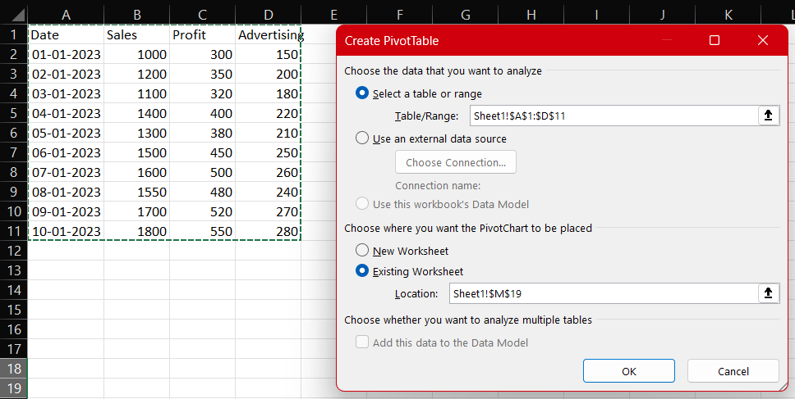

C]Put values in the chart components:

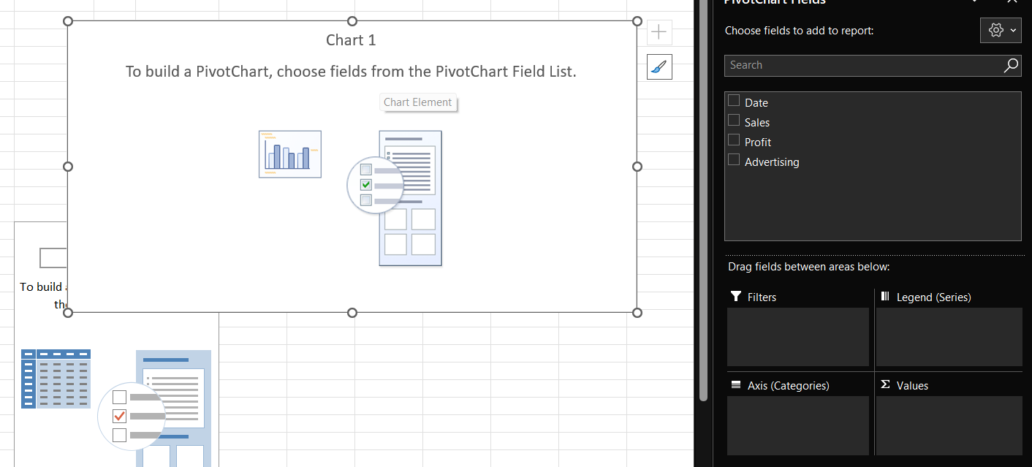

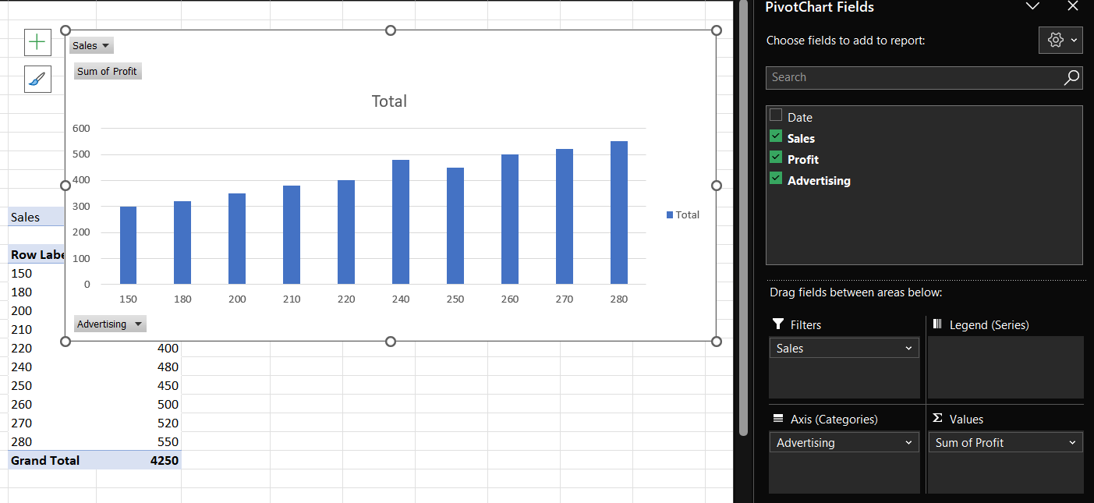

d] Final pivot tble and pivot chart:

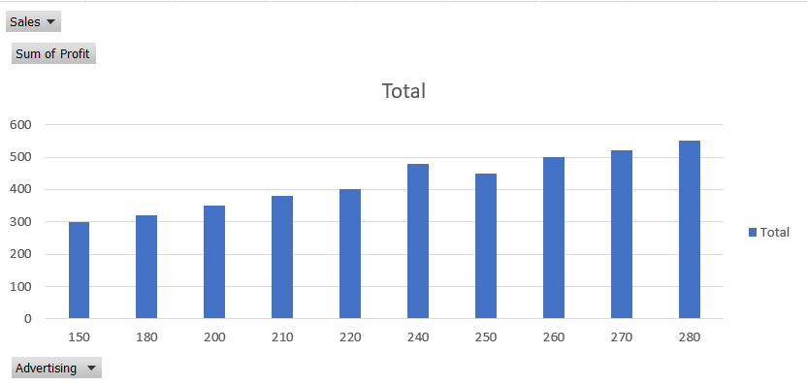 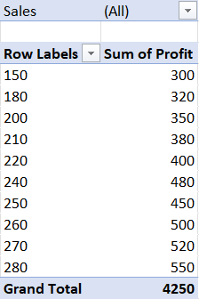

e] Selecting the filter in Sales :

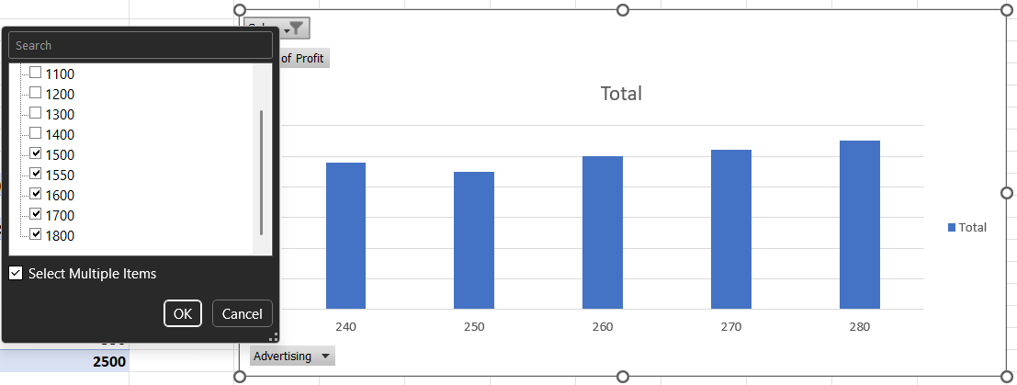

f] Selecting the filter in Advertizing :

